**IoT based weather monitoring system**

**Group Information:-**

|  |  |  |
| --- | --- | --- |
| No: | Team Member Name | Enrollment Number |
| 1 | Honey Bhanushali | 190420116003 |
| 2 | Riddhi Dhanani | 190420116012 |
| 3 | Digal Lakhani | 190420116033 |
| 4 | Isha Narola | 190420116040 |

**Project Description:**

We Make Our project we measure temperature , Humidity ,Rainfall as well as we also measure how much ppm in Air , with help of we know that Air pollution and we also store this all data in cloud .we use Thingspeak cloud and we use Node MCU ESP8266. We also use sensors like DHT11, Rain Sensor, and MQ2 sensor .We also analyse dataset and make some decision and based on that we can make its application also.

**COMPONENTS OF OUR PROJECT:**

|  |  |
| --- | --- |
| **No** | **Component Name** |
| 1 | Node MCU Esp8266 |
| 2 | Breadboard |
| 3 | Jumperwires |
| 4 | DHT11 Sensor |
| 5 | Rain Sensor |
| 6 | MQ2 Sensor |
| 7 | LED |

**We use Thingspeak Cloud For Store Data which is sense By Sensors.**

**Detailed of each components:**

**Node MCU ESP8266(WIFI module):-**

The NodeMCU (**N**ode **M**icro**C**ontroller **U**nit) is an open-source software and hardware development environment built around an inexpensive System-on-a-Chip (SoC) called the ESP8266.

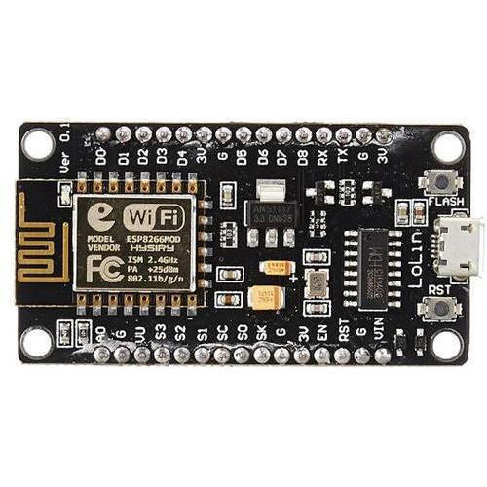

**BreadBoard:** **Jumper Wires:**

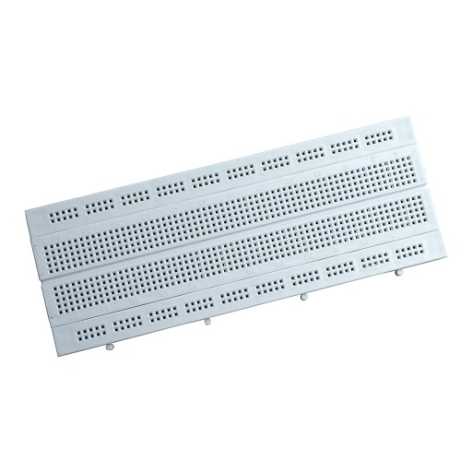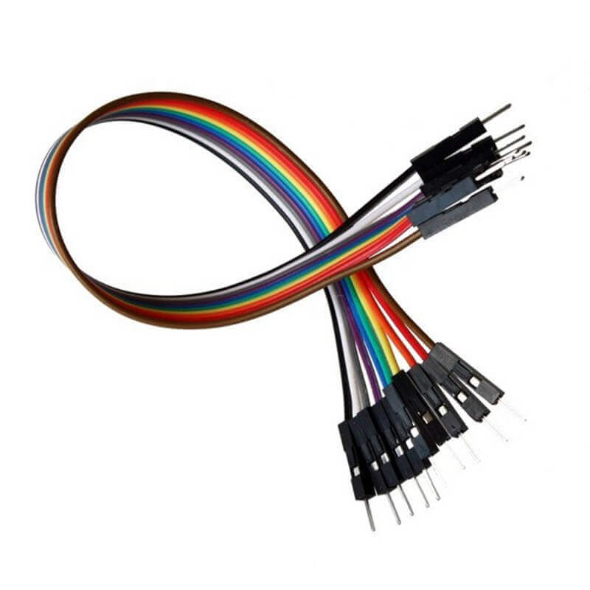

**DHT11 Sensor:**

The DHT11 is a basic, ultra low-cost digital temperature and humidity sensor. It **uses a capacitive humidity sensor and a thermistor to measure the surrounding air and spits out a digital signal on the data pin** (no analog input pins needed). It's fairly simple to use but requires careful timing to grab data.

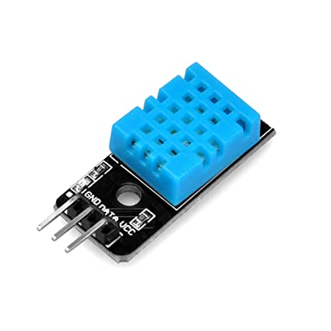

**Rain Sensor:**

Here is [a sensor](https://www.elprocus.com/different-types-of-sensors-used-for-building-projects/) namely rain sensor which is used to detect the rain and generate an alarm. So, we can conserve water to use it later for different purposes. There are several methods available for conserving water like harvesting, etc. Using this method we can increase the level of underground water.

* This sensor is used as a water preservation device and this is connected to the [irrigation system](https://www.elprocus.com/smart-irrigation-system-using-iot/) to shut down the system in the event of rainfall.
* This sensor is used to guard the internal parts of [an automobile](https://www.elprocus.com/different-microcontrollers-used-in-automobiles/) against the rainfall as well as to support the regular windscreen wiper’s mode.

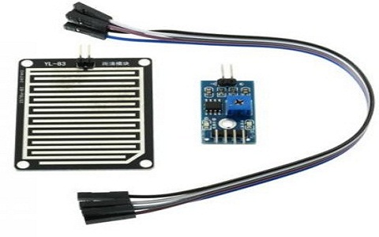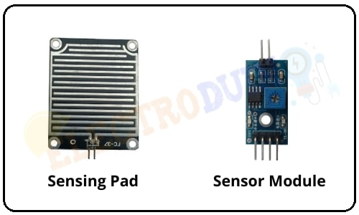

**MQ2 Sensors:**

The MQ2 sensor is one of the most widely used in the MQ sensor series. It is a MOS (Metal Oxide Semiconductor) sensor. Metal oxide sensors are also known as **Chemiresistors**because sensing is based on the change in resistance of the sensing material when exposed to gasses.

The Grove - Gas Sensor(MQ2) module is useful for gas leakage detection (home and industry). It is suitable for detecting **H2, LPG, CH4, CO, Alcohol, Smoke or Propane** **Carbon Monoxide** concentrations ranging from 200 to 10000 ppm.

MQ2 gas sensor detects multiple gases, but cannot identify them! That is normal; most gas sensors operate in this manner. Therefore, it is best suited for measuring changes in a known gas density rather than detecting which one is changing.Its Basically use for Air pollution Monitoring we use it is for monitoring Air Quality- AQI.

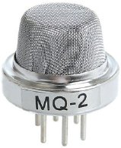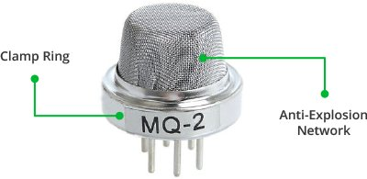

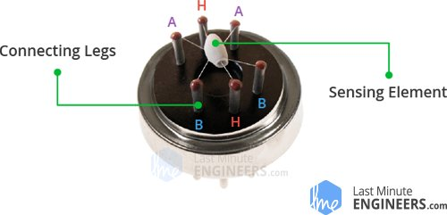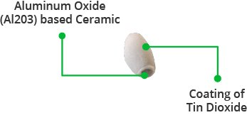

**LED:**

We use Led For taking Decision that AQI level is moderate or intermediate or its dangerous.

Red led-dangerous

Green led-moderate

Blue led-intermediate

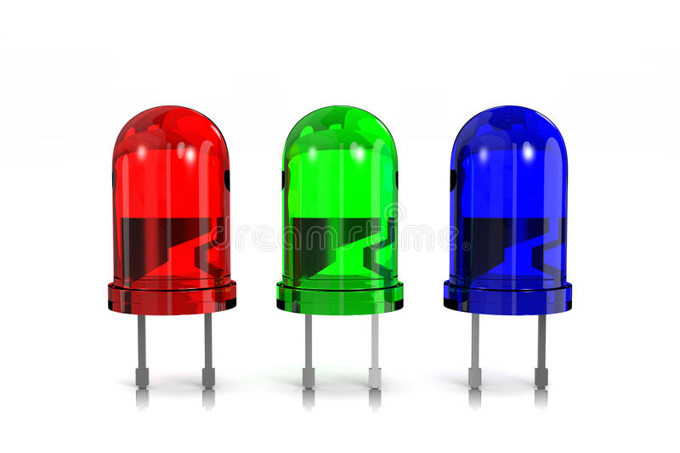

Code:

#include<ESP8266WiFi.h>

#include<ThingSpeak.h>

#include<DHT.h>

#include "MQ135.h"

DHT dht(D3, DHT11);

//DHT objectname(pin,versi-on/DHT11);

float h, t;

int r;

//Wifi setups

char* ssid = "OPPO A5s"; //(hotspot ssid or name)

char* pswd = "ishanarola"; //(hotspot password)

WiFiClient client;

char ip[] = "184.106.153.149"; //ip address of thingspeak

long id = 1841453; // channel id

char* api = "TYJJ6RZ1QDWD5GZP"; // api key

int gled = D7; //green led connected to pin 6

int rled =D6;//red led

int wled=D5; //blue led

void setup() {

// put your setup code here, to run once:

Serial.begin(9600);

//Serial.println("Connecting to WiFi");

pinMode (gled,OUTPUT);

pinMode(rled,OUTPUT);

pinMode(wled,OUTPUT);

WiFi.begin(ssid, pswd);

// while(WiFi.status()!= WL_CONNECTED){

// Serial.print(".");

// delay(500);

// }

//Serial.println("WiFi connected");

ThingSpeak.begin(client);

dht.begin();

}

void loop() {

// put your main code here, to run repeatedly:

if (client.connect(ip, 80)) {

//DHT sensor

h = dht.readHumidity();

t = dht.readTemperature();

//Rain sensor

r = analogRead(A0);

r = map(r, 0, 1024, 0, 100);

//MQ sensor

MQ135 gasSensor = MQ135(A0);

float air_quality = gasSensor.getPPM();

float AQI=air_quality;

Serial.print(h);

Serial.print(",");

Serial.print(t);

Serial.print(",");

Serial.print(r);

Serial.print(",");

Serial.println(AQI);

//store value into Thingspeak Cloud

ThingSpeak.setField(1, t);

ThingSpeak.setField(2, h);

ThingSpeak.setField(3, r);

ThingSpeak.setField(4,AQI );

//channel id and Api key

ThingSpeak.writeFields(id, api);

//for taking Decision

if(AQI >= 200 && AQI<=5000)

{

//for normal level green led glow up

digitalWrite(gled,HIGH);

digitalWrite(rled,LOW);

digitalWrite(wled,LOW);

Serial.println("AQ Level Normal");

}

else if (AQI > 5000 && AQI < 7000)

{

//for moderate level glow blue led

digitalWrite(gled,LOW);

digitalWrite(rled,LOW);

digitalWrite(wled,HIGH);

Serial.println("AQ Level Medium");

}

else

{

//for danger level red led glow up

Serial.println("AQ Level Danger!");

digitalWrite(rled,HIGH);

digitalWrite(gled,LOW);

digitalWrite(wled,LOW);

}

}

delay(1500);

}

**Circuit Diagram:**

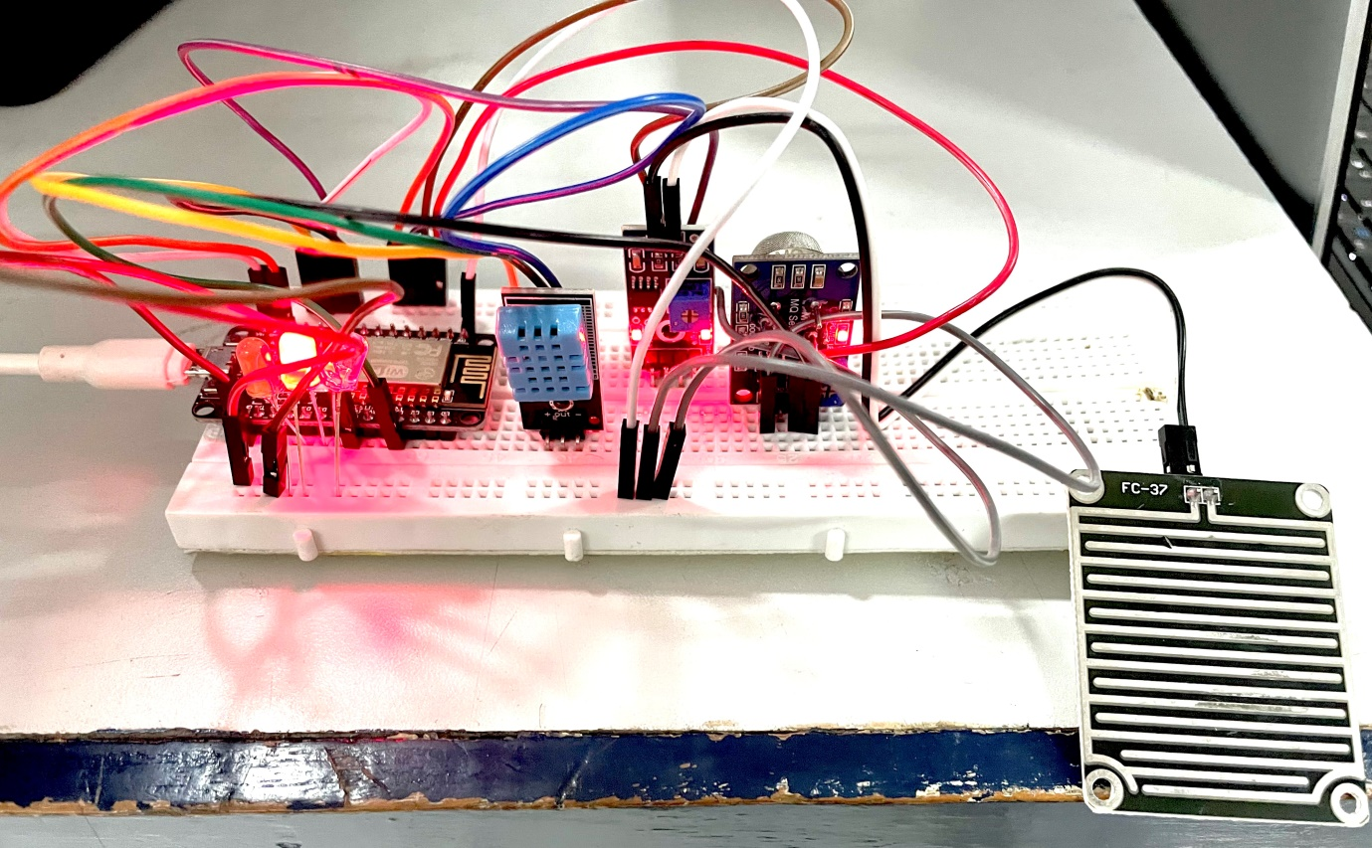

**Cloud :**

First Setup channel:

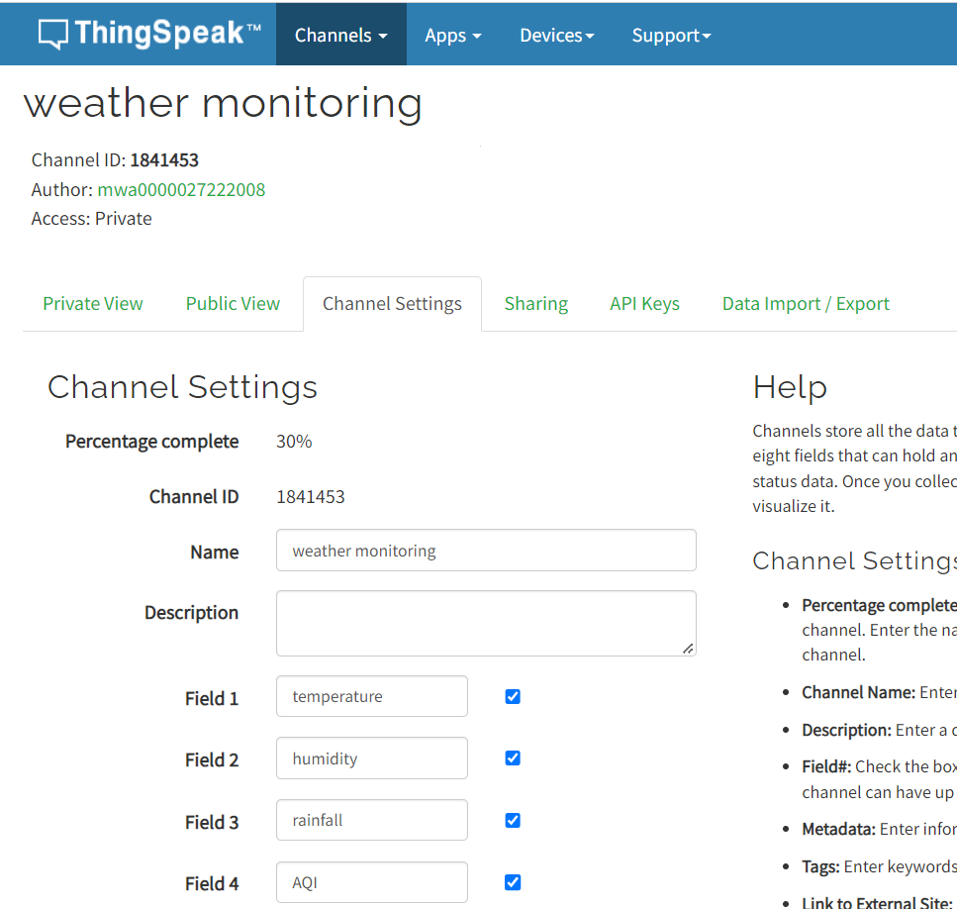

Getting API Key:

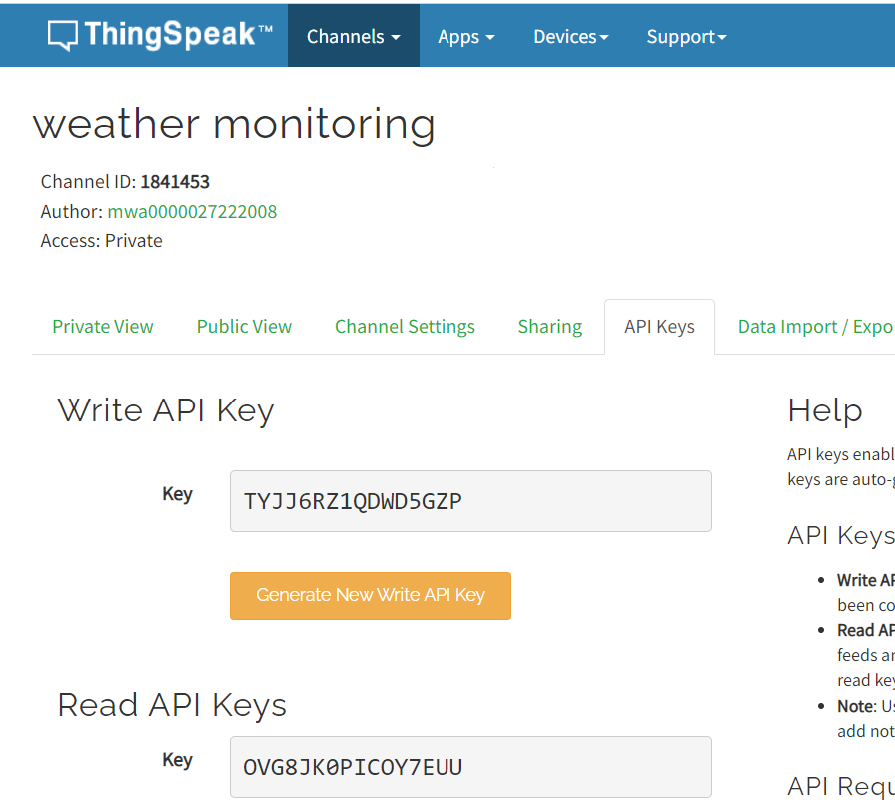

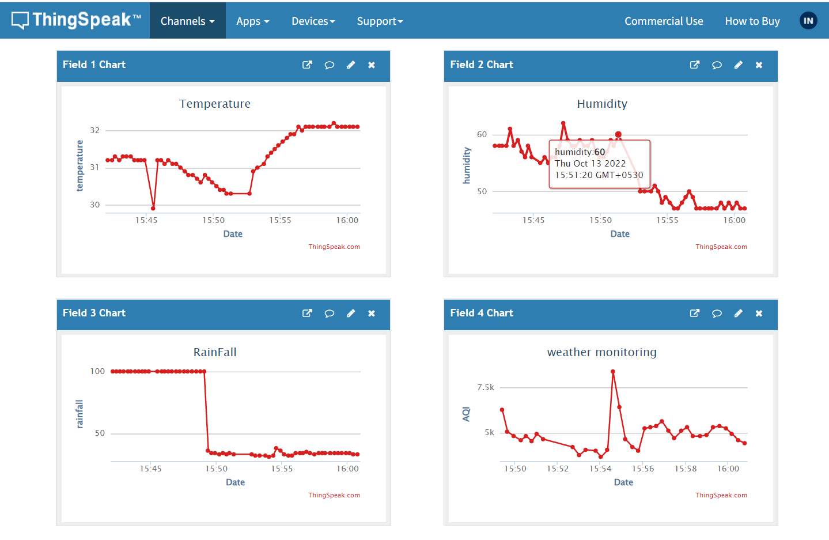

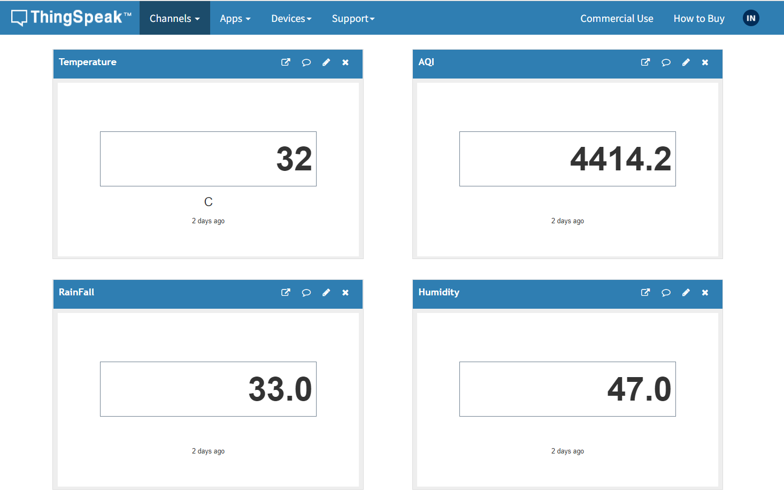

We can also see dataset using this link:

<https://thingspeak.com/channels/1841453/import_export>

**Conclusion:**

In This project we measure temperature, Humidity With help of DHT11 , Rain fall detect using Rain fall Sensor and also we monitoring Air Quality Using MQ2 sensor.